**Overview**

A **for each loop** is a special type of loop specifically designed for traversing arrays.

Consider this basic for loop:

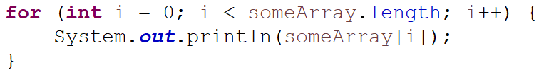

It prints all of the items in the array.

Here is a for each loop with **identical behavior**.

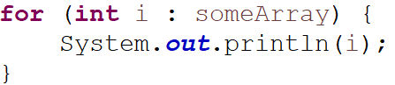

This loop also prints all of the items in the array. It can be read as:

**For each integer (i) in someArray**.

The variable declared in the loop (in this case an integer called i) will store each element of the array starting at index 0 and counting up to index length-1.

So on the first iteration of the loop: i = someArray[0]

on the second i = someArray[1],

then i = someArray[2] etc

**Limitations of For Each**

For each loops are primarily used for convenience and to make code faster to read and write.

A regular for loop can solve all of the same problems a for each loop does.

However, there are some problems a regular for loop solves that a for each does not.

**For each loops do not let you modify the array**

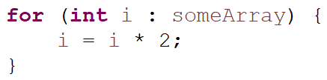

This modifies the temporary iterator variable, not the value stored in the array.

**For each does not keep track of the index**

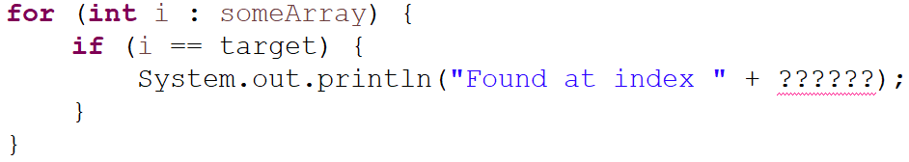

Say you wanted to find the index of a specific integer. You couldn't do that with a for each loop.

**For each only iterates forward in single steps**

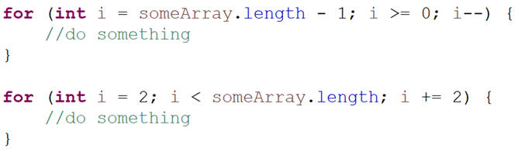

These two loops **cannot** be easily converted into for each loops.